# Studying the Projectile of a basketball

# Introduction

I have come to know Math as an elegant description of nature. It is present in every leap of a gazelle and every falling drop of rain. Certainly, it is also at the core of the dynamics of any football or basketball. Projectile motion is no exception. A basketball’s trajectory is merely an expansion of a parabolic curve, and therefore, it can be graphically modelled. Projectile motion will be defined as the parabolic displacement of an object when it is launched, as a product of its weight, and thereby its reaction to Earth’s gravitational acceleration. Precisely, in this investigation, the infamous metaphor “what goes up must come down” (NASA, 2019) is embraced to a literal degree.

## Rationale

Regardless of its apparent fame amongst “easiest topics for Math IAs” in websites, I chose this topic because it largely relates to my Higher-Level Physics course, and within it, many aspects of Engineering, which I will later study in university. Moreover, it includes basketball, which I strongly pursue on a day-to-day basis, and look forward to continuing to do so in the future. I am currently the captain of my school’s basketball team and the option of relating something outside my academic world with something within it intrigues me. Honestly, the math behind it might help to get a better outlook on the 3-dimensional space that constitutes a basketball court.

## Aim

Through this paper, I intend to study and model the mathematical trajectory of a basketball. I will consider the movement of a ball thrown at different angles from the same place and reaching the same target: the theoretical basket. The points from which the balls are released, and reach are kept the same all throughout. Evidently, my methods may disregard real life factors that largely influence projectile motion, which is partially excused by the limited number of resources available to me at the time.

As I started to ponder on the mathematical approach I would use to confront this investigation, it was obvious that quadratic functions would play a substantial part. Many, if not all, factors of the space analyzed will be modelled after my school’s basketball court’s dimensions. The ball is to be released 5 meters away from the basket and must reach a basket 3 meters high. The variable D defines the horizontal distance from the basket and H is the height. The basket’s coordinate can be written as B (0, 3), also expressed through vector , or 3j. Also, as an analytical material, I will use the website “Desmos.com” to explore and display graphs and their properties.

As stated before, this paper will model and study the trajectories of different balls released from the same position at the 3-point line, swishing through the net. Translating to mathematical language: different negative quadratic curves intersect at 2 non- symmetrical points.

# Methodology

Firstly, I used trial-and-error with a graphic calculator to acquaint myself with the intersecting of quadratic parabolas. I was able to graph different negative parabolas that intersect at two points. I then started to think of conditions that 3 or mote functions obeyed in order to intersect at the same different points. Interesting results were found.

### Figure 1: stacking

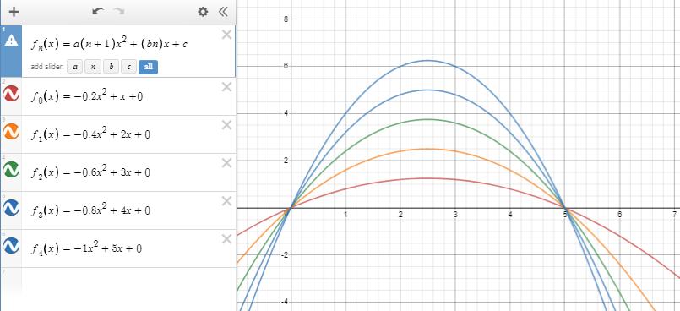

As shown in Figure 1, the negative parabolas intersect at point (0,0) and at (5,0). The individual quadratic functions are written in the form:

All of them pass through the origin of the graph, given that the y-intercept “c” is 0 (c=0), and further along the x-axis (Nielsen, 2015). The second x-axis interception can be calculated through the division , where “a” is the first quadratic, and “b” is the second linear coefficient of a standard form quadratic function, both of which belong to real numbers ().

However, I managed to draw other quadratic functions with different maximums on top of the other, overlapping at 2 chosen points. I then started to think of their relation to each other, which helped to write a formula that would serve to me as a sequential range of functions. According to my observations, these functions, and infinite more placed in the same manner, all obey my presumed distortion of the standard form quadratic equation:

As all of them had different colors and were fixed in an arc-like fashion, I found myself helplessly relating it to a rainbow. Hence, the form made by the parabolas could be equally divided by a vertical line, in this case x=2.5, making it symmetrical. And as symmetry is often related to aesthetic “perfection”, it compelled me to refer to this so-called discovery as the “Perfect Rainbow Model”, where I call the “perfect rainbow number”, which is a real number(), and defines the position of an individual function, within the possibility of infinite others obeying the same conditions. The value of “a” here is negative because it describes the trajectory of basketball, however the numerical value is simply hand picked. Therefore, any other number could be used, as long as the other terms of the function are properly adjusted.

The maximums of the parabolas are joined by a vertical line in the middle of both x- axis interceptions. This is expressed through the derivative of all the functions as

As a note, I would like to express my uncertainty on whether this and future elements in my work have been discussed previously in any published research paper. After failing to find a rule or research regarding this, I gave these conditions and their properties a name in order to easily relate to them, however they may very well have an official name and belong to an official theorem.

=0

Where x would specifically be 2.5, regardless of the the function has. However, it must not be forgotten that even though x remains constant, y does changes, making the coordinates of the functions’ maximum in the form of (2.5, y). Further illustration is shown below:

### Figure 2: maximums of all parabolas in the same x-value

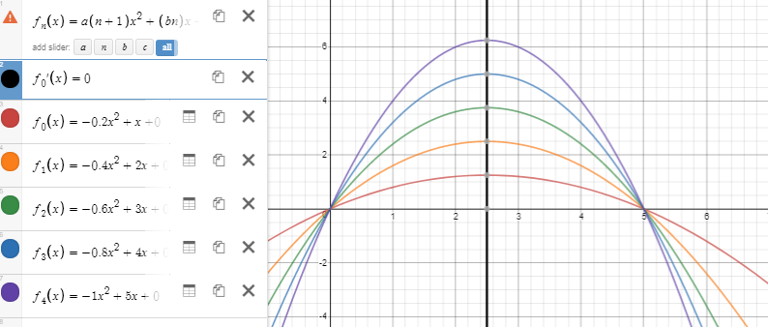

As these may work as sequential formulae, I took the liberty (even more, yes) to establish some terminology to describe the root of subsequent formulae. I consider the “preliminary function” and any other values of the “subsidiary functions”. These will be used for future analogy.

The shape’s symmetry took me to realize that the area under it would also be symmetrical. This could be partially expressed through the process of indefinite integration, and the antiderivative form (Fikhtengol'ts and Silverman, 1971)

Moreover, the area can be more specifically defined through definite integration in the form of (Crook, 1940), therefore

Where 0 is “a”, which is the lower limit of integration, and 5 is “b”, the upper limit of integration, since it is the area under the curve between 0 and 5. These values are used because x=5 is where the ball is released, and x=0 is where the target is placed.

Then, I started to think about a possible large reach of values, and how that would affect the area of the curve. I believe that as the parabola’s maximum increases, the more it will resemble a triangle. Eventually, it will reach a point at which a triangle would be a fairly accurate assumption to define the curve, and particularly, an isosceles triangle since the shape is symmetrical. Then, the formulae for the area of triangle would eventually be useful to describe the area under the curve

The different properties of the preliminary, and its 5 subsidiary functions are shown below with their respective properties.

### Table 1: properties of “perfect rainbow” functions

|  |  |  |  |  |
| --- | --- | --- | --- | --- |
| Function | Derivative | Maximum  =0  (x, y) | Indefinite integral | Definite integral |
|  |  | (2.5, 1.25) |  | 4.17 |
|  |  | (2.5, 2.5) |  | 8.33 |
|  |  | (2.5, 3.75) |  | 12.5 |
|  |  | (2.5, 5) |  | 16.7 |
|  |  | (2.5, 6.25) |  | 20.8 |
|  |  | (2.5, 7.5) |  | 25.0 |

As shown through Table 1, as the value of increases, the area under the curve increases. The shifts in maximums can be described by vector in column vector form as

This means that for every increase or decrease of the value of by 1, the maximums of the parabola’s y-axis position changes by 1.25 meters. This could be represented through an arithmetic sequence in the form as

The arithmetic sequence is then adjusted to fit into this particular case. There is also an apparent change in the derivatives. A graphical representation is below:

### Figure 3: derivatives of the “perfect rainbow” functions

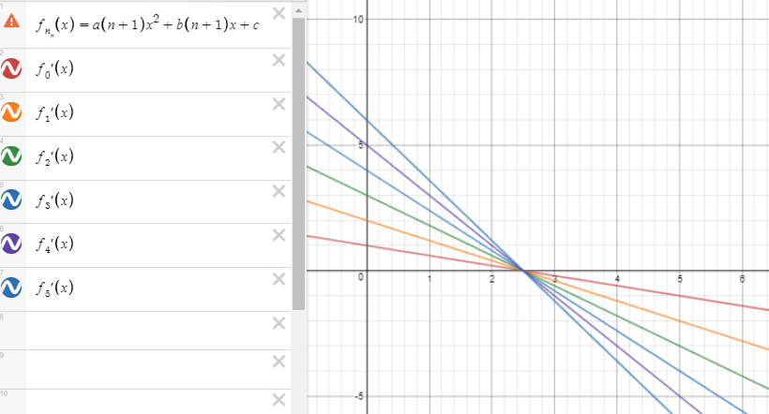

It is evident that as increases, gradients of the lines representing the derivative, or the second derivative, of the particular function increases as well. This makes the gradient of function increase. All of them intersect at the same value at the x-axis, 2.5m, which makes sense, since the first derivative of the functions is 0, and it is where they have their turning point (also known as vertex). Moreover, each individual line forms a right-angle triangle with the x and y-axis, which makes it susceptible to the application of trigonometric tools. All of these properties can be reversed to find the subsidiary or preliminary function, that is, if they belong to range of functions that obey the “perfect rainbow” model.

However, there were still numerous factors that made this model too unrealistic. Many more adjustments would be needed for a more accurate model of a basketball’s trajectory. For instance, “c” was kept as 0, which it should not be because the target is well above the ground. Likewise, where the ball is released is also above the ground, as it considers the where the player releases the ball. For my studies, this was taken as 2m ± 0.05m, because as an educated assumption, someone who is 1.70m tall could throw the ball 30 cm above their head. Furthermore, where the ball is released is lower than the basket, which interferes with the symmetry previously observed. Therefore, I encountered myself with a different manipulation of a quadratic function, which I called the “Imperfect Rainbow Model”.

### Figure 4: parabolas intercepting asymmetrically

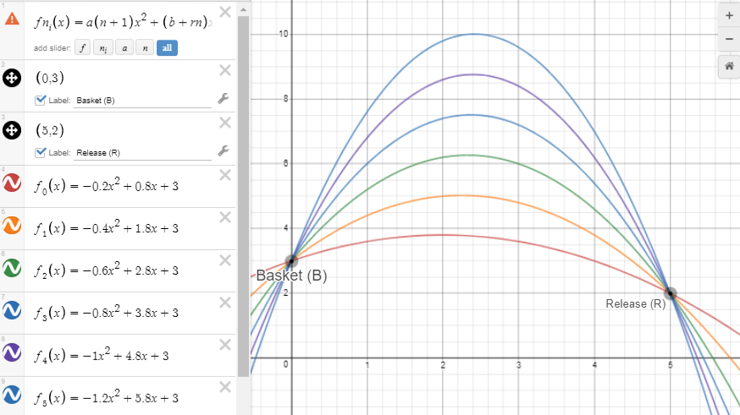

As I researched about parabolas and their asymmetrical interceptions I did not find any explicitly helpful data, therefore I decided to use trial-and-error once more. I was looking for parabolas that were placed above each other, and that intersected at different values of the y-axis. Once I miraculously (ironically, since it’s math) plotted it, I noticed that they obeyed a different alteration of the quadratic equation

Where is the “imperfect rainbow number”, that has the same meaning as a in the function, and describes the position of the subsidiary function within the possibility of infinite others. “r” is a real number (), and is what I baptized as the “imperfect factor”, which in this case is 1 (r=1), and defines the value that has to multiply with in order to get the second term of subsidiary functions. For a different range of functions, it can change. It can be calculated with the maximum of the parabola, using the first derivative

=0,

“c” is the y-axis intercept, which is equivalent to the y-axis position of the basket. Therefore, in this case it will always be 3, since the basket is placed at 3m ±0.5m above the ground. This is seen in Figure 4 through the previously mentioned coordinates of the basket, point B (0, 3). The second interception can be calculated through a formula I call the “Imperfect Second Interception”

I came across it quite logically. I noticed that for the average standard form quadratic function, the ratio of the second to the first terms were need to determine the 2nd x-axis interception. Therefore, I started to divide the second term by the first one and noticed a pattern. Instead of focusing on their signs, I only took into account their numerical values (, ), which gave me positive results. This is shown in the table below:

### Table 2: thought process of “ISI”

|  |  |  |  |
| --- | --- | --- | --- |
|  |  |  | ISI |
|  | 4 | 1 | 5 |
|  | 4.5 | 0.50 | 5 |
|  | 4.67 | 0.33 | 5 |
|  | 4.75 | 0.25 | 5 |
|  | 4.8 | 0.20 | 5 |
|  | 4.83 | 0.17 | 5 |

To find the y coordinate of the ISI, a simple function evaluation can be done for any of the individual quadratic equations. Something that struck me as logical, yet amusing, was the maximums of the “imperfect rainbow” functions. Unlike the “perfect rainbow” functions, both x and y coordinate values change. They are obtained through the first derivative as I equaled them to 0, as

Furthermore, like the previous procedure, the area was represented through integrals. Through indefinite integrals, the model takes the form

However, this did not precisely define the area under the curve. To do that, I had to use definite integrals in the form

As before, the values “0” and “5” where chosen as the lower and upper limits of derivations because at 0 is where the basket is, and the ball is released 5m away from it.

### Table 3: properties of “imperfect rainbow” functions

|  |  |  |  |  |
| --- | --- | --- | --- | --- |
| Function | Derivative | Maximum  =0  (x, y) | Indefinite integral | Definite integral |
|  |  | (2, 3.8) |  | 16.7 |
|  |  | (2.25, 5.03) |  | 20.8 |
|  |  | (2.333, 6.28) |  | 25.0 |
|  |  | (2.375, 7.51) |  | 29.2 |
|  |  | (2.4, 8.76) |  | 33.3 |
|  |  | (2.417, 10.0) |  | 37.5 |

The maximum theoretical area of the ball’s projectile would consider the maximum of graph as being in 2.5 in the x-axis, because the higher the of , the closer the maximum would be to 2.5 in the x-axis. A seen in table 3, the increased, and the line representing the derivative became steeper, and the area under the curve increased.

### Figure 5: preliminary function’s maximum to relation to line x=2.5

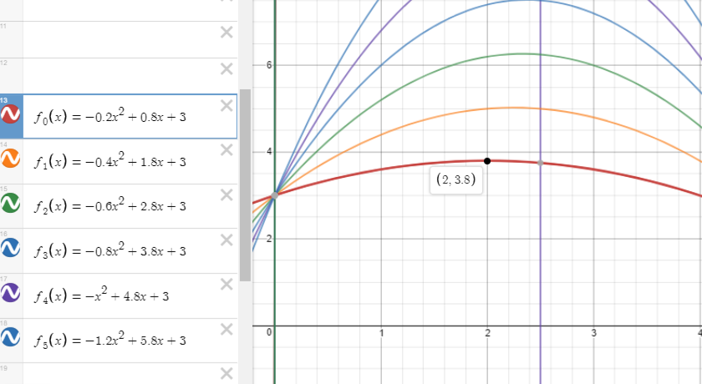

As seen in figure 4, functions with low values of , such as the preliminary function , have their maximums’ x-coordinate away from 2.5.

### Figure 6: subsidiary function’s maximum to relation to line x=2.5

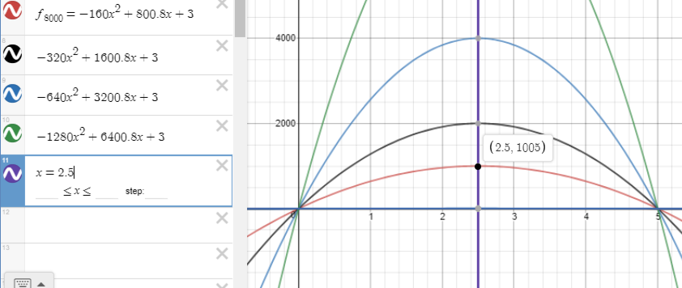

However, for =8000, the maximum x coordinate is 2.5. I believe there may be a slight decimal difference, however this is negligible.

Theoretically if the value of is big enough, the shape should also resemble a triangle’s, which makes it susceptible to the application of a triangle’s area , as an equivalent to the definite integral. However, the base is an inclined straight line, and the graph is translated by vector , which affects the area to respect to the ground. Because of this, the area of a trapezium, or a rectangle with a triangle, will need to be added.

This is more explicitly shown below:

### Figure 7: area under the curve

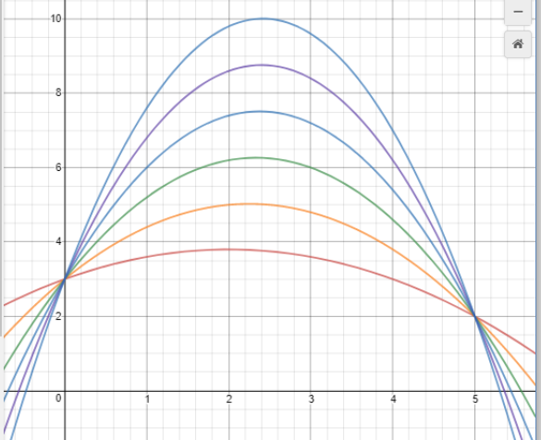

The triangle’s area would be

And the rectangle’s area would be

Both of these would have to be added to the areas under the curve to get a more practical value.

### Figure 8: derivatives of the “imperfect rainbow” functions

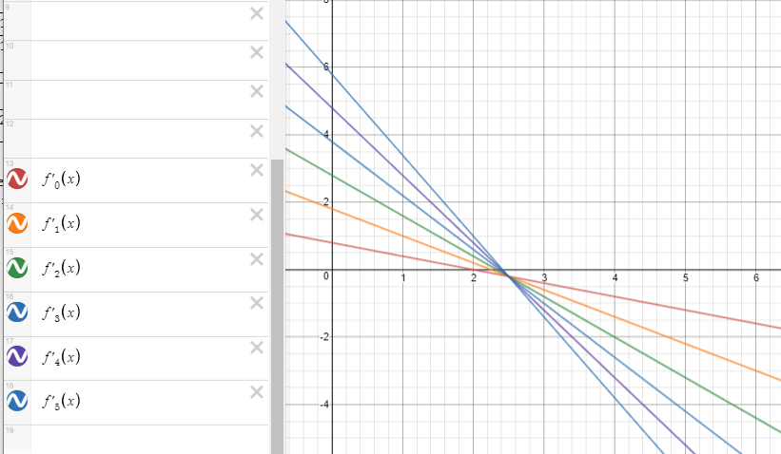

Like in the “perfect rainbow” models straight lines represent the straight line functions that define the derivatives, however, even though they pass through the x- axis, the lines do not intercept each other in the x-axis. This means that they have different values for =0, that justifies the maximum shift, for both the x and the y coordinates.

#### Figure 9: maximum shift of the “imperfect rainbow” functions

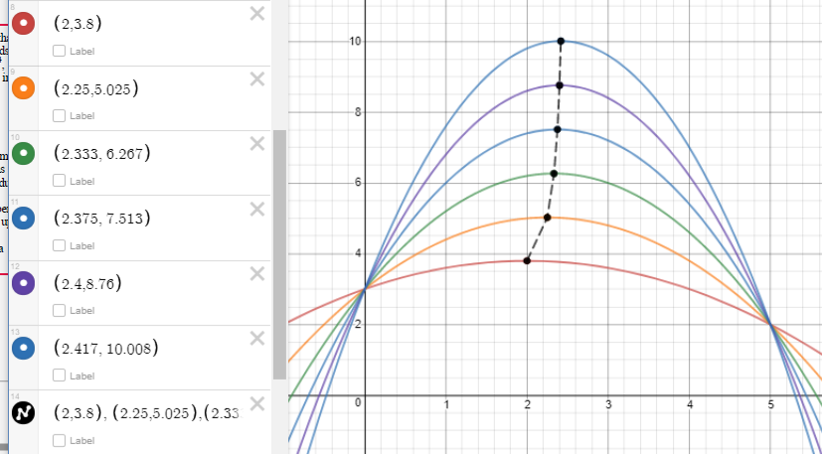

Even though I was not able to find a numerical shift in maximums in terms of vectors, I noticed a that as the maximums increased, the shift in x the coordinate decreased. The change in maximum looks like the shape of a rational function in the form (Shilov and Kisin, 1982), which I was able to adjust to

As demonstrated below:

### Figure 10: modelling of the maximum shift of the “imperfect rainbow” functions

I placed the value at the best of my abilities to make it as relatable to the maximum shift possible. Evidently the asymptote will be at 2.5, because when x=2.5 the denominator is 0, which defines the vertical asymptote. This differs from the “perfect rainbow” function, as their maximums are placed right on top of each other.

With this, I concluded my study. I felt somewhat proud of what I had accomplished, as the outcome personally seemed denser than my initial expectations. Since my research did not blatantly rely on data, I sought to rely on a more theoretical approach. However, this may very well be applied to real data to analyze the difference between the theoretical and practical scenarios.

# Conclusion

I carried out this investigation to model and better understand the math within the projectile motion of a basketball. While I think I succeeded in this, there are areas in which future researchers, or myself, could dare to study with more depth, such as the areas of vectors, trigonometry and infinite integrals. First, I came across a symmetrical model of the trajectory of a ball, which seemed too unrealistic to be compared to the real life, also, it disregarded essential properties of the projectile motion such as the height of the target and the initial position of the ball. Then, I made a more realistic model with the adequate properties. For both, I briefly mentioned the hypothetical result of their areas, in the case in which large values were considered. Essentially, the properties of the first and second models had explicit differences and that made the former a poor approximation to real life. I also, swum my way through finding what I called the “perfect and imperfect rainbow” models, which at the end served as extremely helpful tools.

Overall, I do not believe that I explicitly learned new mathematical content. Instead, I applied different areas of content that helped to describe certain situations, which gave me a more whole picture of the trajectory of a ball. When I was thinking about the possible simplicity of the topic, I did not dream of including some things I did. Also, at first, I was considering a much more experimental approach, which involved me spending countless days the school court. As much as that could have helped me for future games, it would only be increasing the human error, making my whole investigation less reliable. However, the path I took at the end showed more promise than others alternatives, which makes me glad I took it.

Nevertheless, the real world always has factors which affect any theoretical analyses. Some of the factors are product of nature itself, such as air resistance, whilst others are caused by human error, such as a miscalculation. In this investigation for instance, if applied to the real world there would be a lack of consistency as the maximum of the function increased, because in the atmosphere there is a point at which the Earth’s gravitational acceleration is no longer 9.81m. However, that only comments on the environmental factors. A basketball is actually influenced by numerous forces and factors: drag, Magnus, Buoyant, its weight (not to be confused with its “mass”) and its velocity (Cruz-Garza, 2019). More importantly, as a basketball player I cannot disregard the use of spin when shooting a ball, since it is one of the most unconscious actions in basketball, yet, one of the most influential ones. These have helped me to realize that no regardless of how careful you may be, there are always uncertainties working against the accuracy of your results.

Even though I may have not learnt how to integrate to infinity or to disprove a complex model, I did learn how to see numerous methods and tools within one situation. Having successfully modelled and studied the projectile of a basketball, I feel somewhat accomplished and being able to see in real life is even better. I wish to later on encounter an actual theory that includes what I have encountered myself with, in order to appreciate the thorough thought process that went to concluding it. Meanwhile, I shall keep visualizing parabolas every time someone shoots at the basket.

# Work cited

NASA (2019). [online] Nasa.gov. Available at: https://www.nasa.gov/pdf/544893main_PS2_Projectile_flight_C4_Final.pdf [Accessed 21 Jan. 2019].

Nielsen, L. (2015). [online] Digital.lib.washington.edu. Available at: https://digital.lib.washington.edu/researchworks/bitstream/handle/1773/33799/Nielsen_washington_0250E_14987.pdf?sequence=1 [Accessed 20 Jan. 2019].

Fikhtengol'ts, G. and Silverman, R. (1971). The indefinite integral. New York, N.Y.: Gordon and Breach Science Publishers.

Crook, F. (1940). Definite integrals.

Shilov, G. and Kisin, V. (1982). *Calculus of rational functions*. Moscow: Mir.

Cruz-Garza, J. (2019). Forces acting on a basketball in flight. [online] Physics of Basketball. Available at: https://physicsofbasketball.wordpress.com/2014/05/18/forces-acting-on-a-basketball-in-flight/ [Accessed 20 Mar. 2019].